**Web Application Development Group Project**

**Jorge Vargas**

**Ankur Maloo**

**Mayank Badika Ananth Ramaswamy**

**Description**:

Our project proposal is to create a pizzeria vendor reviews. The web application is focus in specific locations in the Salt Lake City area. The top 5 pizzeria vendors have contracted us, to provide customer feedback and reviews. The vendors will want to obtain the amount of reviews our website receives. They will provide payment to us based in the amount of reviews we receive from each vendor. The web application site needs to be simple and user friendly for the customer experience. The site will have pizza vendor description, rating, and customer comments.

**Motivation:**

The web application would help to promote the top vendor list, and advertise new offers and promotions. The vendors would like to take advantage or website marketing, therefore attract more customers to their website across the Salt Lake City community. Over the past years the online marketing has grown, and more and more customer are ordering their food online. This adds to the potential benefits of having a web application to promote marketing. The web application will have the data stored in the database which will generate a report, and be provided to the vendors to get information about the customer comments, rating, analytics, and predictive analytics

**Benefits:** The benefits of creating the web app, is to get more customers to the vendors. The user will enjoy the experience to choose to rate their favorite pizza vendor, and be connected to the vendor main website to place a pizza order. The vendors, will benefit from the customer information reviews, provided by our website.

**Implementation plan**:

1. Obtain the user requirements

2. Business requirements

3. Design pages

4. Contents

5. Styling

6. Link pages with each other

7. Front-end validation using JavaScript

8. PHP working MySQL – population and querying data

**Database model architecture:**

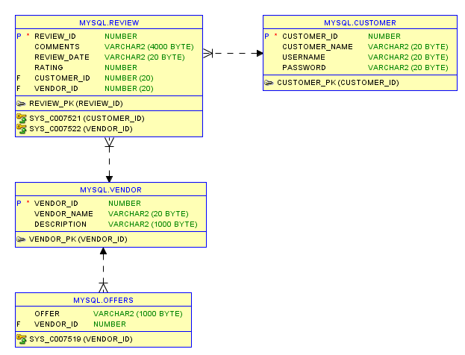

**Web Application Framework**

1. Page 1 – Home

|  |
| --- |
| Header |

|  |
| --- |
| Section  Login and Register  Google:Maps Link: Rate Now |

|  |
| --- |
| Footer |

1. Page 2

|  |
| --- |
| Header |

|  |
| --- |
| Section  List of vendors |

|  |
| --- |
| Footer |

1. Page 3

|  |
| --- |
| Header |

|  |
| --- |
| Section   1. Picture of vendor 2. Vendor description 3. Link to vendor site 4. List of reviews – Add, Update, Delete |

|  |
| --- |
| Footer |

**Anticipated challenges:**

1. Meeting Deadlines.

2. Organizing meeting for project proposal.

3. Gathering the data.

4. Working with different programing languages.

5. Understanding the business needs, and scopes.

6. Making the web application user friendly

**Tentative delivery:**

1. 11/12 - Proposal due Data

2. 11/23 - Mid-term Project Presentations

3. 12/10 - Final Project Presentations

4. 12/10 - Project Files due